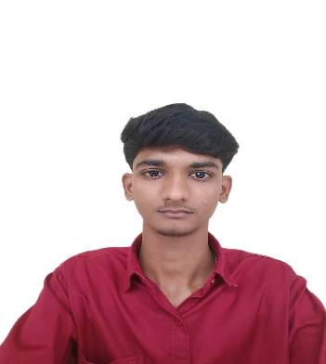**DHARANIDHARAN D**

**Contact:** 7695943302

**Email:** dharani7695@gmail.com

**LinkedIn:** https://www.linkedin.com/in/dharanidharand76/

**Github:** https://github.com/dharan2ii

**CAREER OBJECTIVE:**

Technically adept with a Bachelor of Engineering in Computer Science and Design with a keen interest in data-driven solutions and resource efficiency, aiming to contribute technical and analytical skills to an innovative organization

**EDUCATIONAL BACKGROUND:**

|  |  |  |  |
| --- | --- | --- | --- |
| Qualification | School/College | Year of Passing | CGPA/Percentage |
| B.E (Computer Science and Design) | Karpagam Academy of Higher Education | 2026 | 7.77* |
| HSC | MSP Matriculation Higher Secondary School | 2022 | 60 |
| SSLC | Achyuta Academy Matriculation Higher Secondary School | 2020 | 78.2 |

**PROJECT DETAILS:**

**Title:** CHATBOT FOR CUSTOMER SUPPORT

**Abstract:** Developed an AI-based chatbot that automates customer service interactions, providing instant responses to frequently asked questions and basic troubleshooting. Integrated with a backend database for storing user interactions and feedback.

**Used:** Python (Flask), TensorFlow (for NLP), JavaScript (Node.js)

**INTERNSHIP:**

**Full Stack Development Internship at CodeHub**

Interned at CodeHub for 15 days, where I gained hands-on experience in full stack web development. Worked extensively with React on the front end and Node.js with Express on the back end. Enhanced my skills in building RESTful APIs, database integration with MongoDB, and deploying applications to cloud platforms. Improved my ability to debug and optimize application performance for a seamless user experience.

**TECHNICAL SKILLS:**

**PROGRAMMING LANGUAGE:**

* C
* PYTHON

**WEB TECHNOLOGY:**

* HTML
* CSS

**DATA BASE :**

* MySQL

**AREA OF INTEREST:**

* **UX/UI Design**
* **Cloud Computing and DevOps**
* Web Development

**CERTIFICATES:**

* Certified in ‘C fundamentals’ by Infosys.
* Certified in Artificial Intelligence Primer Certification by Infosys ,2023.
* Certified in SQL - basics by HackerRank ,2024.
* Certified in React JS for Beginners by Simplilearn ,2024.

**PERSONAL SKILLS:**

* Innovative Thinking
* Conflict Resolution
* Creativity
* Presentation skills

**DECLRATION:**

I hereby declare that all the information furnished above is true and correct to the best of my knowledge and belief.

**Place:** Coimbatore [Dharanidharan D]

**Date:**